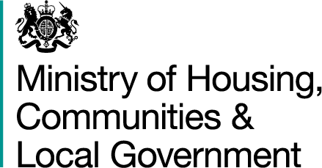

**Robert Jenrick**

*Secretary of State for Housing, Communities and Local Government*

***Ministry of Housing, Communities and Local Government***

4th Floor, Fry Building

2 Marsham Street

London SW1P 4DF

Tel: 0303 444 3672

E-Mail: robert.jenrick@communities.gov.uk

[www.gov.uk/mhclg](http://www.gov.uk/mhclg)

19 January 2021

Members of Parliament in England

Dear Colleague,

Today I have announced the next set of measures as part of our ongoing commitment to make buildings safe. We will tighten regulatory oversight of construction product safety, so that people can feel confident that the products used to construct our homes will perform as they should.

**A strong national regulator for construction products**

The Building Safety Bill will strengthen and extend construction product regulations, requiring manufacturers to ensure that their products are safe before putting them on the market. To ensure that these regulations are effective they must be robustly enforced - shocking recent testimony to the Grenfell Inquiry has shown that some manufacturers of safety critical construction products appear to have put lives at risk by gaming the system. That is why we are establishing a national regulator for construction products to oversee the sector and work with industry to stamp out the rotten culture exposed by the Grenfell Inquiry. The regulator will have strong inspection and enforcement powers, so that it can hold those who put profits above safety to account - and deter those who would otherwise seek to circumvent the rules. The regulator will also have the capability to test construction products to investigate issues of non-compliance, and will carry out vital market surveillance to ensure that we can detect and respond to systemic failures sooner.

**Going further on product testing**

I am also commissioning an expert led independent review to examine in detail the deficiencies in the testing regime for construction products, and to recommend how we can ensure that the public can be confident that the products that make it onto the market will perform as required and as advertised – and, most importantly, keep them safe. The review will report later this year and may lead to further regulatory changes.

**Ongoing work to improve building safety**

These measures come on top of other major steps we are taking as we deliver our commitment to bring about a generational shift in building safety, including:

* £1.6 billion of funding to remove dangerous cladding from high rise buildings
* Introducing the Building Safety Bill and Fire Safety Bill to bring about the biggest change in building safety for a generation
* Establishing a new Building Safety Regulator
* Recruiting the first ever Chief Inspector of Buildings

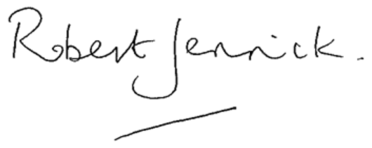

**RT HON ROBERT JENRICK MP**