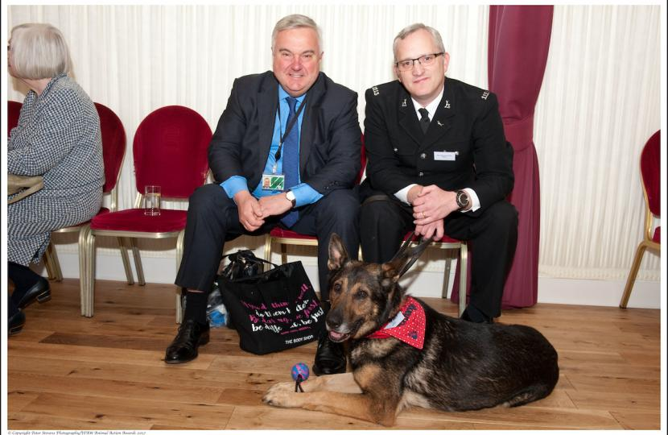
On Tuesday 5 December, North East Herts MP, Sir Oliver Heald, will put forward a motion in the House of Commons for permission to bring in a Bill, The Service Animals Offences Bill, which would make it an offence to attack service animals, including police dogs and horses, and to make certain offences aggravated when perpetrated against such animals. This could also cover guide dogs and assistance dogs.

Commenting Sir Oliver said, “My constituent, PC Dave Wardell and his police dog Finn live in Buntingford in my constituency. Finn was extensively injured when he was stabbed in the chest in course of his duty, in trying to apprehend a suspect and protect PC Dave Wardell, who suffered an injury too. Finn made a great recovery and returned to service. However, it was only possible to charge the accused with criminal damage - treating Finn as an object, or with animal cruelty which fails adequately to take account of his service duties.

The aim of the Bill is to create offences of attacking service animals in the course of their duty. This is something which happens in Canada and other countries. It is time we had such a law in this country.”

The photo shows PC Wardell with Finn and Sir Oliver at a recent House of Commons Award Ceremony where Finn was named Action Animal of the Year by IFAW.

